Payroll Management System for Information Technology Company

s

Version 1.0

Revision History

|  |  |  |  |
| --- | --- | --- | --- |
| **Date** | **Version** | **Description** | **Author** |
| 28/12/2019 | 1.0 | Final | Nguyen Khac Phuc |
|  |  |  |  |
|  |  |  |  |
|  |  |  |  |

Table of Contents

1. View all reports 4

1.1 Brief Description 4

2. Flow of Events 4

2.1 Basic Flow 4

2.2 Actor 4

3. Special Requirements 4

4. Preconditions 4

5. Postconditions 4

6. Extension Points 4

# View all reports

## Brief Description

This use-case defines the step of view all of the reports. Admin can easily see reports so that he can modify or see the information of reports.

# Flow of Events

## Basic Flow

* Users log in with the admin account. Admin clicks manage salary button, then click view all reports button, all of the reports will show on the view

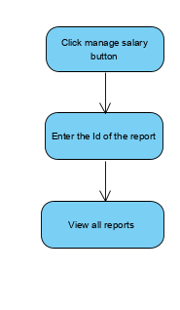

## Actor

-Administrator

# Special Requirements

# Preconditions

* User must log in into the system with the admin account

# Postconditions

* Show all the reports or show nothing if there is no report in the database

# Extension Points